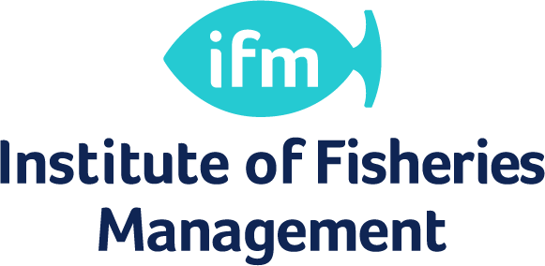

IFM Award – Module Descriptions

Water Quality
By the end of this module you will be enabled, as demonstrated through completion of exams, to:
1. Outline the basic properties and natural characteristics of water of particular importance fish and other aquatic organisms (Chapter 1)
2. Describe how water quality is affected naturally by interacting hydrogeomorphological and biological factors that produce different types of ecosystems, zones and characteristic fish communities in rivers, estuaries and lakes (Chapter 2).
3. Define what is meant by pollution and outline the principal types, causes and effects on fish, direct and indirect (Chapter 3).
4. Outline some key EU and UK legislation and management principles and options available to protect aquatic environments and fisheries (Chapter 4)

Freshwater and Fish Biology
By the end of this module you will be enabled, as demonstrated through completion of exams, to:
1. Describe the basic common features of living things and the differences between plants and animals
2. Understand and describe the basic anatomy of fish and the key differences between the most common groups of fish in the British Isles
3. Understand and describe why nutrients and chemicals are important to freshwater biology and how they are recycled
4. Describe the different types of aquatic plants and how and why they are important to freshwater ecosystems and fisheries management
5. Describe the different types of aquatic invertebrates and how and why they are important to freshwater ecosystems and fisheries management
6. Describe basic food webs and the interaction between different types of organisms in the aquatic environment
7. Understand why a knowledge of Freshwater Biology is essential to fisheries management
Fishery Law
By the end of this module you will be enabled, as demonstrated through completion of exams, to:
1. Understand and describe the main provisions of the Salmon and Freshwater Fisheries Act, 1975.
2. Be able to interpret sections of this Act, especially in relation to their effects on fishery owners, occupiers and managers, and fishermen.
3. Have an understanding of other legislation that relates to fisheries management.

Fish Culture and Husbandry
Fish farming is an important part of fisheries management, particularly with the restocking of fish following pollution incidents and trying to improve or develop angling facilities. The understanding of fish farming is therefore important for any fisheries manager and this module is designed to inform student about the main types of farming in the UK, and their relevance to fisheries management.
By the end of this module you will be enabled, as demonstrated through completion of exams, to:
- Describe the production cycles and biological requirements of the major farmed species in the UK.
- Understand the artificial propagation of Salmon and carp.
- Describe the tagging and marking of fish and the production of triploid salmonids.
- Outline the various stocking methods for Salmon

Angling and Recreation
This unit is often a favourite of those taking the Certificate course if they have come to fishery management through angling as a hobby. The successful fishery manager must appreciate the different types of anglers and their interests along with the needs of other users such as walkers and boaters.
This module gives you the skills and knowledge to operate confidently in this sector of the industry.

Fisheries Maintenance and Improvement
This unit of the course will deal principally with the practical measures that could or should be undertaken to maintain or improve the physical condition of a fishery; i.e. methods to improve conditions for fish and techniques to improve conditions for the angler in order to create a more productive fishery. It is perhaps the key section of the Certificate in Fisheries Management, as it describes practical measures that can be taken to improve a fishery, using the knowledge drawn from each of the other sections of the course.
The unit describes the different types of fisheries found in the British Isles and the main environmental requirements of fish in them. It then goes on to present the many methods available to improve the fish holding, or production capacity of a water and attention is also given to the techniques that can be used to improve facilities for anglers. The methods available to monitor and assess the degree of success of any improvements are presented and lastly, the legal requirements and political considerations are discussed.

Fishery Enforcement
One of the main roles for any fishery manager is informing customers and enforcing any rules and relevant legislation. This unit will attempt to cover the area sof enforcement – i.e. the enforcement of fishery rules and relevant legislation. It will therefore relate to the work undertaken in controlling and managing access to the site and the angling activities. This will cover the activities of specialist enforcement officers such as a "Water bailiff" in Scotland (a person appointed by a District Salmon Fisheries Boards under the 2003 Act to enforce the provisions of current salmon fisheries legislation anywhere within that DSFB’s district or adjacent districts) to fisheries managers who may have to complete some enforcement activities as part of their day job.
The word “Bailiff” does have a legal meaning, in Scotland a bailiff is a warranted law enforcement staff member. However, the term Bailiff is commonly used to describe other fisheries staff working on fisheries that do not have a warranted law enforcement duty. For example, on a private fishery the fisheries manager may employ someone to ticket collect and enforce the fisheries rules. This person may be called a bailiff even though he has no warranted powers. Therefore, the term water bailiff or fisheries worker used here does not mean a warranted bailiff

