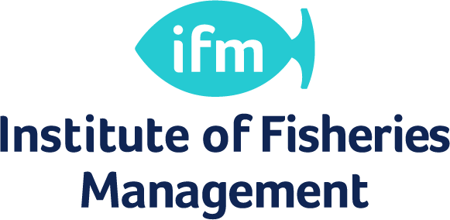

Scheme of Continuing Professional Development
INFORMATION AND RECORD

The IFM has accepted the principle of Continuing Professional Development (CPD) as:

“the systematic maintenance, improvement and broadening of knowledge and skills and the development of personal qualities necessary for the execution of professional and technical duties throughout a practitioner’s working life.”

Empowering Professionals in a Dynamic Environment

Continuing Professional Development (CPD)

Starting CPD

CPD is now operational.

- CPD is a voluntary scheme.

Members can record CPD on-line via the IFM web-site and are advised to obtain and retain some independent proof of events. Members can also request to be issued with new CPD record sheets like these with their renewal material.

Completed CPD records may be returned to the IFM. The scheme will be reviewed from time to time.

Guidelines

It is recognised that professionals cannot expect their initial qualifications and training to equip them for their entire working life. Maintaining professional competence requires a continuous focused commitment to learn and develop new skills and abilities. CPD enables this development.

CPD Credits
Credits are awarded for qualifying activities. Members are required to obtain 60 credits (equivalent to 60 hours or 8 days of CPD) over a 2 year rolling period. Members will be required to include activities from at least 3 categories in their CPD. One credit is awarded per hour spent on an activity, except for transferable skills category where 1 credit is awarded per 2 hours. At least half of an individual’s credits must normally come from fisheries management activities. Provision has been made for maternity leave, a sabbatical period or long term sick leave where members can have a maximum of 2 years break from CPD.

CPD Categories and Sub-categories:
1. Work based learning – scientific or technical knowledge gained through performing the current work role.
Includes:
  - Experience gained through current work role e.g. where the role is expanded to include new areas of work;
  - Receiving coaching;
  - Shadowing colleagues or others in a relevant field of work;
  - Presentations to colleagues, clients, stakeholders;
  - Secondments & sabbaticals;
  - Scientific or technical training courses provided by current employer;
  - Supervising students undertaking projects in the workplace;
  - Membership of a technical expert panel or focus group;
  - Requesting and acting on feedback regarding performance in specific projects or areas of work.

2. Professional activity – taking part in the management, organisation or activities of a professional fisheries related body.
Includes:
  - Involvement in the work of a professional body e.g. Institute of Fisheries Management (IFM), as an officer or committee member;
  - Organising a conference, seminar, scientific meeting or other event on behalf of a professional body;
  - Acting as an examiner or invigilator on behalf of a professional body.

3. Knowledge transfer – improving own and others understanding of fisheries science and related topics.
Includes:
  - Attendance at conferences and seminars to broaden fisheries science knowledge and understanding;

  - Presenting at conferences and seminars;
  - Running workshops and training courses;
  - Liasing/networking with peers;
  - Tutoring or lecturing (if this is not part of your job description).

4. Academic – working towards academic qualifications. Preparation of papers and articles for a professional audience.
Includes:
  - Writing articles or journal papers;
  - Learning or research for an academic qualification;
  - Acting as a referee for a journal;
  - Reviewing scientific or technical books;
  - Supervising scientific research (if this is not part of job description)

5. Private study – where an individual has identified knowledge gaps and learning needs. A statement of the aims of, and reasons for, the work should be made.
Includes:
  - Reading books, journal papers and articles.

6. Transferable skills or other activities – activities which do not require scientific knowledge but will help to develop valuable transferable skills for current or future career direction. Any activities which do not fit into the other categories.
Includes:
  - Leadership, (project) management, finance or legal courses;
  - Interpersonal skills or communication skills courses;
  - Auditing activities;
  - Voluntary work in support of sustainability, environmental or conservation charities.

The CPD Framework
The content and subject area of your CPD activities should be relevant to your personal role, or professional development aims. Activities can be broadly grouped into three categories:
- Fisheries Management
- Environmental management and sustainable development
- Personal skills and competencies (e.g. IT skills, Project management, etc)
A minimum of 50% of credits must come from activities directly related to fisheries management.

Recording CPD
There is no fixed method of recording CPD, but you are recommended to use this layout as a basis for your own record. Records can also be updated electronically on the IFM web-site, but individuals should retain paper records.
The real value of CPD is obtained by taking a planned approach. By recording CPD intentions in the future, a review of actual CPD activity can help you draw up a structured personal plan for the following year. Missed opportunities or unsuccessful CPD can be revisited and a developing professional will make the best of opportunities ahead with this approach.

Please keep this record in a safe place, so that you can assist in the review of the scheme.

Any queries about this scheme should be sent to cpd@ifm.org.uk

Record of Continuing Professional Development

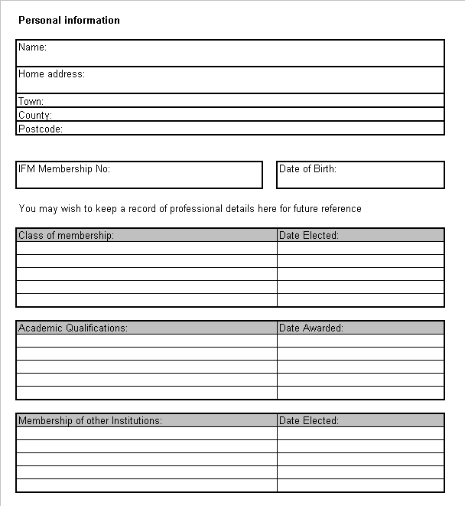

Record of Continuing Professional Development
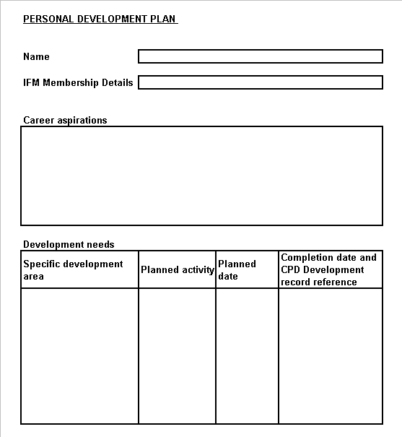

Record of Continuing Professional Development
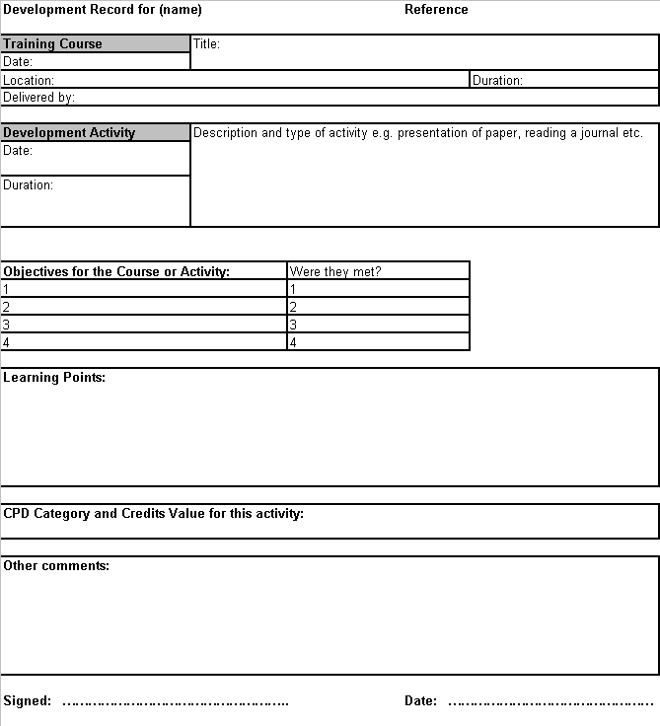

CPD Frequently Asked Questions – Answered!

What is CPD?
Continuing Professional Development is the way in which IFM members maintain, improve and broaden their knowledge and skills, and develop their personal qualities.
Such activities demonstrate commitment to professional competence and development, and the maintenance of high standards.

Why CPD?
One of the Institute’s main roles, in common with most other professional bodies, is to develop, promote, monitor and control the quality and standards of practice of its membership.
As well as setting educational standards for the relevant professional qualifications, the Institute has an obligation to ensure that its members are up to date and developing on a continuous basis. The Institute believes that it can best satisfy that obligation with a scheme of CPD.

The Basis for the Scheme
The rules of the Institute contain a general requirement for full professional members (i.e. registered Members and Fellows) to follow a programme of CPD.
The Institute of Fisheries Management first introduced a voluntary scheme during 2004.

Do other professions have CPD schemes?
Yes most professional bodies have CPD schemes.

What do I have to do?
CPD is measured by credits. Credits are awarded for activities or attendance at events. For a detailed breakdown of events and number of credits awarded refer to the CPD Credit Table enclosed or on the web-site. Credits for IFM functions will appear in FISH magazine.
Members who take part in CPD should complete, and record, at least 60 credits of CPD activity over a two year period.

What sort of activities counts towards CPD?
The Institute believes that the scheme should be as flexible as possible and therefore a wide variety of activities can be included. Research activities, attending seminars, courses or conferences, whether arranged in-house or externally, working on study groups, distance or open learning, structured reading or private study and taking part in training events can all be recorded for CPD purposes. Providing these activities are relevant either directly or indirectly, to fisheries management work, environmental management and sustainable development, or developing personal skills and competencies.

Why should I do CPD?
Firstly the Institute’s own research has shown (Source: - Membership survey April 2001 – Anne Bowden Research Associates) that most of its members agree with the principle of CPD, and the vast majority are also probably achieving significant credits already.
The advantages of undertaking CPD are that it demonstrates the professional commitment of the individual, which is of assistance in career progression, and it strengthens the case for access to training and development on a structured and professional basis.

Will CPD cost me anything?
It should be quite possible to fulfil the CPD recommendation without incurring excessive personal cost, except perhaps for the expense of travelling to branch or national IFM activities. But as there are considerable personal, career and professional benefits to CPD, most members would regard any such costs as incidental.

What if I cannot get the time off for CPD, or if my employer's training budget is not large enough?
Employers are encouraged to support CPD activities as it is to their benefit for employee's skills and knowledge to be continually updated and developed.
However, CPD is not just about attending courses and seminars - the wide range of CPD opportunities should ensure flexibility for the individual who finds access to, or support for, conventional activities restricted.

Only senior colleagues ever get sent to conferences, so it is easier for them to comply than it is for me!
Whilst this may be true, CPD provides a good argument for such nominations to be more selective and varied. Of course, anyone who has attended such an event should be encouraged to provide a briefing session for colleagues. This would provide CPD time for both the 'presenter' and all those attending the briefing session.

I read FISH magazine regularly. Does this count for CPD?
Such reading, which is largely unstructured and a normal professional activity, does not count towards CPD, but certain structured reading linked to a specific project could be recorded. For example, if you are researching for a project which involved a structured literature search through journals.

My local IFM branch never organises any good events, how am I expected to get my CPD credits!
Some branches are more active than others are. This need not be a problem. What about organising an event through the branch yourself. Taking a more active role in your branch will stimulate events and organising events will also count towards your CPD. There are also plenty of other ways of obtaining points

CPD schemes seem to be paper exercises, and it is possible to record 'credits' for attending a poor event, which achieves nothing!
It is very rare for the time spent at such events to be totally wasted, and in any case the value of the event can depend to a large extent on the individual's experience and knowledge.
The most important thing is to recognise such poor quality events and to feed back your comments to colleagues and organisers in order to encourage improvements.
Certainly there is nothing wrong in being selective in your choice of CPD, so that it either assists you in your current work, or expands your knowledge and skill base for possible career development.
The Institute has no desire for the CPD scheme to become merely a 'credits' gathering exercise.

How do I record CPD, and will there be any checks on what I am doing?
You should detail your activities using the CPD record sheet or online via the IFM web-site. You are advised to try and obtain some independent proof of CPD, such as an attendance certificate. Reviews may be carried out to verify the scheme and members may occasionally be asked to make their CPD records available to the training committee. As part of the regular monitoring of the scheme, members will be asked to help in the review of the extent and nature of CPD being undertaken, and make suggestions for changes.

These reviews will also look at the best way of recording CPD that is convenient and acceptable to the membership.

What happens if I do not achieve the required number of credits?
CPD is a voluntary scheme. However the Society for the Environment expects those who qualify for Chartered Environmentalist to undertake CPD as it is available through the IFM. Members who register for CPD but do not achieve the standard required will be asked to provide an explanation. If unresolved, they will be referred to the Committee. Members who do not complete CPD could be transferred to a less senior class of membership with the possible consequential loss of 'Chartered Environmentalist' title. A prospective employer is more likely to look favourably on an applicant for a job who has complied with the CPD scheme than one who has not.

What does the Institute provide to help me achieve CPD?
Attendance at many of the meetings and events organised by the Institute at both regional and national levels will form part of your CPD. Many of these, particularly local branch meetings only make a charge to cover costs of refreshments.

