INSTITUTE OF FISHERIES MANAGEMENT

MINUTES of the forty-ninth Annual General Meeting of the Institute of Fisheries Management held at The Guildhall, Hull on Tuesday 16th October 2018 at 17.40

- APOLOGIES
There were no apologies for absence
2. MINUTES OF THE FORTY FIFTH AGM
The Minutes of the forty-eighth Annual General Meeting of the Institute of Fisheries Management held on Tuesday 10th October at the Hilton Hotel, Belfast were confirmed at signed by the Chairman

3. CHAIRMAN'S REPORT

This is the Chairman’s report to the 2018 Annual General of the Institute of Fisheries Management (IFM). It is structured according to the business areas in our Development Plan. The objective(s) for each business area are provided as a reminder to what the Institute is aiming to achieve in each.
Governance
Objective:
To maintain the best possible structure and practices to ensure the Institute runs professionally and cost-effectively.
Council (30 members) met its usual three times in the year, setting the direction for the Institute, and the Executive Committee (12 people) met its usual four times to follow the business plan and direction set by Council. My thanks to Council Members and Executive Committee for their hard work to provide the best for the IFM.

Finance
Objectives:
To manage our budgets carefully
To achieve a surplus each year and annual growth
The Director of Finance has produced a separate report for the year. I am grateful to Ian Dolben for managing and monitoring the Institute’s accounts so diligently.

Staff & Officers
Objective:
To employ competent full time staff and honorary officers who reflect the diversity of the Institute, are motivated and rewarded, to provide the best possible services to the Institute, its members and customers.
We now have 2 full time staff – Paul Coulson and Iain Turner. After 2 years on a temporary contract, we were pleased to be able to provide a permanent contract to Iain Turner, our Development Officer, in August 2018.
The Institute has 35 officers and 10 committees to perform its duties, and 9 Branches to provide services and activities to members across Ireland and the United Kingdom. Thank you to you all for your often voluntary service to the Institute and its members.
Marketing & communications
Objective:
To promote our services and achievement to our members, customers, partners and policy makers, to raise our profile and be more visible
Our most popular publication, FISH Magazine, went digital in 2018 and 90% of members now receive the electronic version. Thanks for Adrian Taylor for leading that change and to Lawrence Talks for editing a consistently high quality production.
The use of social media such as Twitter and Facebook are becoming much more the norm now, and IFM uses those outlets more and more to publicise events – before and after. To help give this more focus, we welcomed Harriet Alvis to the team as Communications Officer.
We recognise that our website is getting unreliable and clunky. This is our main window for members and customers and is often the first contact people have with IFM – so it is important for it to be effective and professional. So, we started a review of the website and providers for a potential upgrade in the next 2 years.

Training
Objective:
To provide an increasing suite of training courses and workshops to provide professional training to meet a wide variety of customer needs
IFM now provides a wide variety of vocational fisheries management courses. Those provided in 2018 were:
Certificate Course
Diploma Course
Electro-fishing
Effective Engineering within Fisheries
Environment Agency Award
Fisheries Management Workshops
Angling Trust Enforcement Workshops
Angling Trust Fishery Improvement Workshops

With 96 students in 2018, 96 IFM is currently the 2nd largest provider of fisheries training in the UK.
Enrolment to the ever-popular Certificate course continues to increase, as the following graph shows:

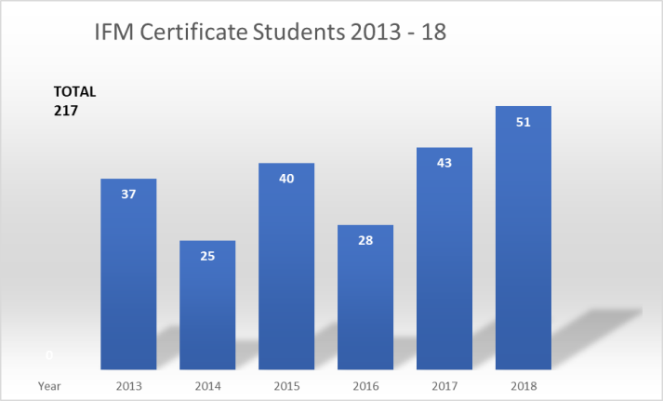
My thanks to Ian Wellby and the Training Committee for their efforts in providing so many high quality courses and developing the fisheries managers of the future.

Conferences & Workshops
Objective:
To provide one annual conference and several specialist conferences or workshops per year
The 2017 annual conference was held in Belfast, and the 2018 conference was held in Hull. A specialist conference, ‘Fisheries Management in Coastal and Estuarine Waters’ was held in May 2018.
IFM also provided a range of workshops for members and professionals to engage in:
Riparian Trees for Upland River Systems Scotland. November 2017
Invasive Non-Native Fish. February 2018
Stillwater Fisheries Management. March 2018
Connecting Rivers, People and Partnerships Midlands. March 2018
Sampling fish – Take a Dip. London. April 2018
Shad workshop, Wales
Otters & Predation. June 2018

Membership
Objectives:
To provide good value and quality services to members
To increase the level and engagement of members

Like many membership organisations, we are concerned at the continued downward trend in our membership as the graph below shows. This, despite the provision of more and better services, discounted to members.
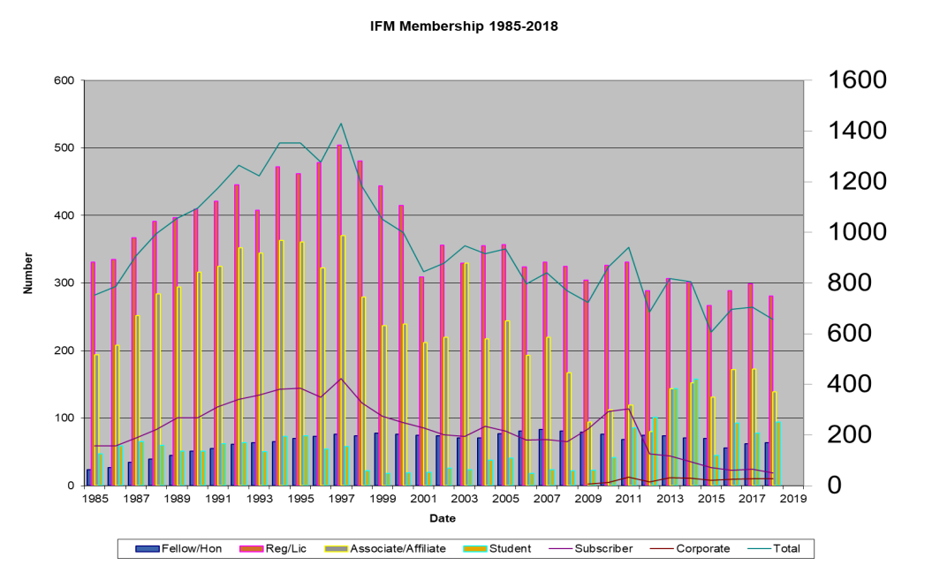

The Membership Committee is developing a strategy to aim to retain and increase membership. Although membership income is decreasing as a result, the balance of income to the IFM is being maintained through the sales of courses, services and conferences to members and non-members.

Professional status
Objectives:
To promote and enhance the professional status of fisheries managers
To be the market leader / go-to organisation for the provision of CPD for fisheries professionals

The Chartered Environmentalist Award (C.Env) continues to be available via the Institute. Most IFM activities carry Continuing Professional Development (CPD) points to help develop and maintain C.Env status for members.
Three new C.Envs were awarded to IFM members in 2018, bringing the total to 114.
However, the C.Env assessment process is long and cumbersome and seen as a barrier to many. So, our C.Env Co-ordinator, Emma Keenan has developed and is trialling a ‘C.Env in a Day’ assessment process. If successful, and acceptable to the Society for the Environment, this will be made available to members.

Branches
Objective:
To provide a network of thriving and active branches to provide local IFM services, activities and networking
The Institute has branches covering the UK and Ireland as follows.
Anglian
Irish
London & South East
Midlands
North West
Scottish
Welsh
South West
Yorkshire & North East

Some branches are more active than others and our full time officers, Paul and Iain support the branches as much as possible to maximise the number of events and local services to members.

Specialist sections
Objective:
To maintain relevant specialist sections to develop and provide technical expertise

We have five specialist sections to advise and lead on fisheries management topics, those are, with their chairs:
Estuarine & Coastal Steve Colclough
Fisheries & the Environment Jim Lyons
Culture & Health Ian Wellby
Angling & Recreation Mike Lee
Administration & Management Steve Axford

Policy development
Objective:
To provide credible and compelling evidence to government and agencies in developing new legislation and policies
Over the past year, IFM has responded to consultations or developed position statements on the following topics.
Fisheries Monitoring
Brexit
Defra 25 Year Environment Plan
UK Fisheries White Paper
Welsh National Marine Plan
Future of IFCAs
Sussex IFCA Inshore Trawling
Otter Predation
EA Managing Salmon Fisheries
EA Coarse Fish Close Season
We have been particularly busy this year due to potential law changes with Brexit, and the development of Defra’s 25 Year Environment Plan. My thanks to Miran Aprahamian, our Policy Director and to Chris Mills and Steve Colclough who each spent significant time developing the IFM’s position on these important topics.
Our statements help to inform and influence government policy and also help to increase the Institute’s reputation as an evidence based, professional, independent and and objective non-government organisation. Our membership of the Wildlife and Countryside Link increases the coverage and exposure to influencing government policy.

Partnerships
Objective:
To work with other organisations, where there is mutual benefit, to progress our objectives
We work with a large number and wide variety of fisheries and conservation organisations around Ireland and the UK. At the Council workshop on 8 October we considered how we might develop partnerships better to maximise the IFM’s effect with its limited resources. A strategy is being developed to put that thinking into action.
Thanks to Nigel Milner who attended the NASCO* meeting in Maine, USA and provided a comprehensive report to Council on NASCO’s progress. * North Atlantic Salmon Conservation Organisation

Business development
Objective:
To identify and make the most of new opportunities to provide services to customers
IFM is constantly seeking opportunities to develop its business – to maintain its viability to provide the best for fisheries management and services to members and customers. A future workshop will focus thinking on this.

And finally
My thanks to all members, officers and staff for their support to the Institute.

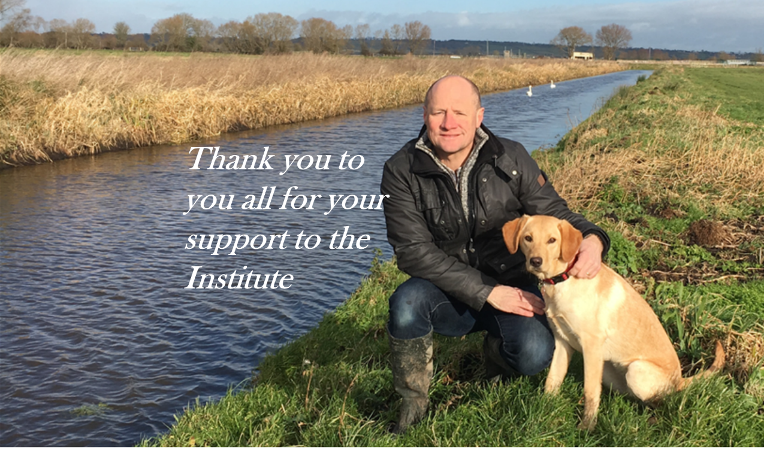 | David Bunt  Chairman

4. TREASURER'S REPORT

This is my first report to the Annual Meeting as Director of Finance – please be gentle!

VAT Liability
The Institute may be liable to pay VAT if its annual turnover is more than £84k. However, there are exemptions for organisations which provide education and/or training. Our accountants, Girlings continue discussions with HMRC on our behalf, using an outline of our work (written by Valerie Holt) making the case that much of our income is derived from education and training. We still await the verdict of HMRC,
2017 Accounts
The Institute receives less than a quarter of our income through subscriptions, the remainder being training (30%) and conferences and workshops (36%). In 2017 income continued to be boosted by the new EA Fisheries course, together with 2 conferences (Renewables, the Annual Conference in Belfast and the incredibly successful Eel conference). Initiating and organising these events takes a considerable amount of time and effort and would not occur without the efforts Paul Coulson and Iain Turner, together with the Training Committee led by Iain Wellby.
Expenditure
In 2017, thanks to the incredibly successful Eel conference, we generated a small surplus.
In conclusion, we continue to move to a better financial position following several years of a very high deficit and a critical look at expenditure, making several changes to save money as well as increasing our income through conferences and courses.
This has only been possible through the efforts of our two fulltime staff, Paul and Iain, and the work of the IFM Training led by Ian Wellby assisted by the team of tutors delivering quality fisheries training. We also need to stabilise and increase our membership.

5. ELECTION OF OFFICERS AND COUNCIL MEMBERS

President: Dr P.B. Spillett

Vice Presidents Dr D. Cragg-Hine, A. Neville Jones, V. Holt, R.L.Welcomme (elected)

For Council vacancies, to retire in 2021

Hannah Barclay, Jim Gregory, David Bunt, Paul Knight, Ian Wellby.

All retiring in accordance with Rule 5(A) but eligible for re-election

It was proposed and seconded that these officers and council members be elected en bloc

6. SUBSCRIPTIONS

Subscriptions to remain the same at :-

Registered Member £70
Associate Member £60
Affiliate Member £35
Student Member £10
Subscriber Member £35
Corporate Member £90 to £170 depending on category

7. APPOINTMENT OF AUDITORS

Andrew M Girling & Co Chartered Certified Accountants were appointed at auditors for the Institute

