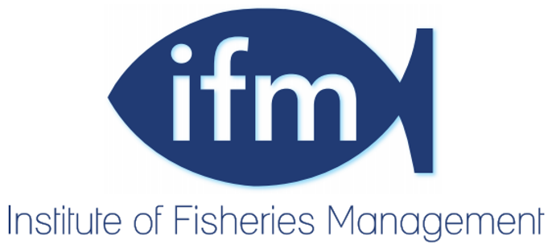
INSTITUTE OF FISHERIES MANAGEMENT

NOTICE TO ALL MEMBERS

The forty-eighth Annual General Meeting of the Institute of Fisheries Management will be held at the Hilton Hotel, Belfast, on Tuesday 10 October 2017 at 17.40.

AGENDA

- Apologies for absence.

- To confirm the Minutes of the forty-seventh Annual General Meeting held on Tuesday 4 October 2016

- The Chairman will present the Annual Report of the Council.

- The Treasurer will present the financial report and accounts.

- Election of Officers and Council members

- President: Dr. P.B. Spillett

- Vice Presidents: Dr. D. Cragg-Hine, A. Neville Jones, V. Holt, R.L. Welcomme

- For Council vacancies, to retire in 2017:

  - *retiring in accordance with Rule 5(A) but eligible for re-election:
Shaun Leonard*, Paul Johnston*, Eamon Cusack*, Nicola Teague*, Robert Clark*.

- Subscriptions

- Council recommends that there be no increase in subscriptions which currently stand at:-
Registered Member £70
Associate Member £60
Affiliate Member £35
Student Member £10
Subscriber Member £35
Corporate Member £90 to £170 depending on category

- Appointment of auditors

Council recommends that Girling & Company Chartered Accountants are appointed as auditors for 2017

David Bunt,
Executive Director

