INVITE - The 2017-18 Integrated Catchment Delivery events team invite you to:

FREE – IFM Midlands workshop: connecting rivers, people and partnerships

A national inclusive event hosted by Institute of Fisheries Management

Programme for 21st March 2018 ………………… for bookings
Venue: Loughborough University, Stuart Mason Building, LE11 3TU

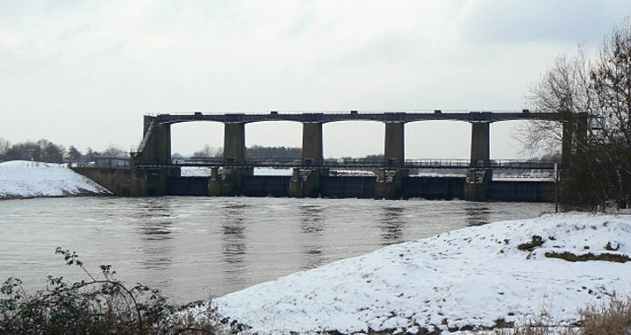

Integrated Catchment Delivery Events purpose:
Over 360 people have attended the first six events, this has enabled us to:
- Share evidence, good practice and embed learning at a catchment scale and
- Build future relationships between communities, institutes and partnerships

Shared IFM Midlands workshop goals
- Inspiring and motivating people to achieve great fish passage projects
- Better understanding of fish passage and wider benefits to people and wildlife from working to shared visions and common goals
- How to open up fish passage innovatively working with others
- Overcoming barriers to delivery and capitalise on future opportunities
- Connecting people to make this happen

Outputs available after the event on the River Restoration Centre website:
- Presentations
- Web links to useful information

Programme: Wednesday 21st March
From 09:00 Arrive, introductions, tea and coffee

Session 1. Connecting rivers and partnerships, Chair RFCC/CIWEM
- 09:50 Welcome
- 10:00 Improving ecological connectivity – overview Martyn Lucas, University of Durham
- 10:30 Unlocking the Severn, partnership working – Richard Harrison, Canal and Rivers Trust
- 11:00 Discussion

11:10 Tea and Coffee

Session 2. Evaluation and opportunities, Chair RFCC/CIWEM
- 11:30 Creamery weir removal, lessons learned – Dan Smith and Claire Rodgers, Royal HaskoningDHV
- 12:00 Appraising and evaluating fish passes Hull International Fisheries Institute
- 12:30 Workshop and discussion

13:30 Lunch provided, networking and poster session

Session 3. Current practice and future thoughts, Chair Clare Rodgers
- 14:30 Arborfield weirs, wet woodland and nature-like bypass channel - Dominic Martyn, Environment Agency
- 15:00 Wissey siphon fish pass Kye Jerrom, Environment Agency
- 15:30 Discussion and poster prize
- 16:30 Close

Thank you for coming, safe journey and please hand in feedback form

Thank you to our Sponsors for making this workshop free to attend
